SYED RAYYAN
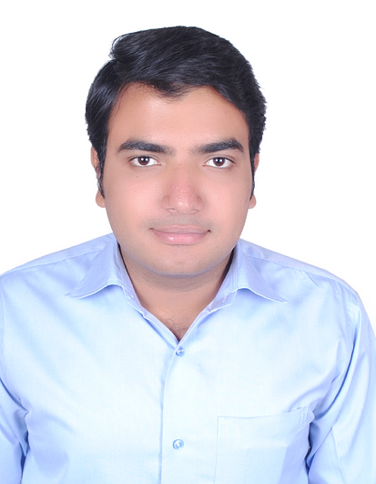 Contact No. 9557490348
Email: rrrayyan@gmail.com
CAREER OBJECTIVE:
Seeking Senior Design Engineer’s position in an esteemed engineering firm which provides an opportunity to work with professional in a competitive environment resulting in a job satisfaction and add personal growth.

WORK EXPERIENCE:
Organization - A R Infrastructure, Delhi
Designation - Structural Engineer
Work duration - 2+ Years (Nov. 2016 - Present)

Organization - Unique Group, Aligarh
Designation - Site engineer
Work duration - 1 Year (Oct. 2015- Oct. 2016)
Duties - Execution of RCC Building

SUMMER TRAINING:
Organization - Holtec Consulting Pvt Ltd, Gurgaon
Designation - Trainee
Work duration - 7 Weeks (Jun. 2014 – July 2014)

EDUCATION:
Bachelor of Technology (Civil)
University - AKTU, Lucknow
Duration - 4 years (2011-2015)
Marks - 75%

Senior School Certificate Examination (12th)
Board - CBSE
Duration - 1 year (2010-2011)
Marks - 64%

Secondary School Examination (10th)
Board - CBSE
Duration - 1 year (2008-2009)
Marks - 65%

ACADEMIC PROJECT:
“Analysis and Design of Residential Buildings on STAAD Pro”
Components designed under this project are:
- Beam
- Column
- Slab
- Staircase

IT SKILLS:
AutoCAD
STAAD Pro
Revit
Robot
SAGA GIS

PERSONAL DETAILS:

Profile Male, 26, unmarried
Nationality Indian
Father’s Name Salahuddin Mushtaq
Languages Known English, Hindi

DECLARATION:

I hereby declare that the above furnished details are correct and true to the best of my knowledge and belief.

SYED RAYYAN

